Animal Cell Colouring KEY
Cell Membrane(light brown) | Nucleolus (black)
Cytoplasm (light yellow) | Golgi Apparatus (pink)
Nucleoplasm (pink) | Flagella (red/blue striped)
Nuclear Membrane(dark brown) | Rough Endoplasmic Reticulum (dark blue)
Ribosome (red) | Smooth Endoplasmic Reticulum( light blue)
Microtubules (dark green) | Lysosome (purple)
 | Mitochondria (orange)
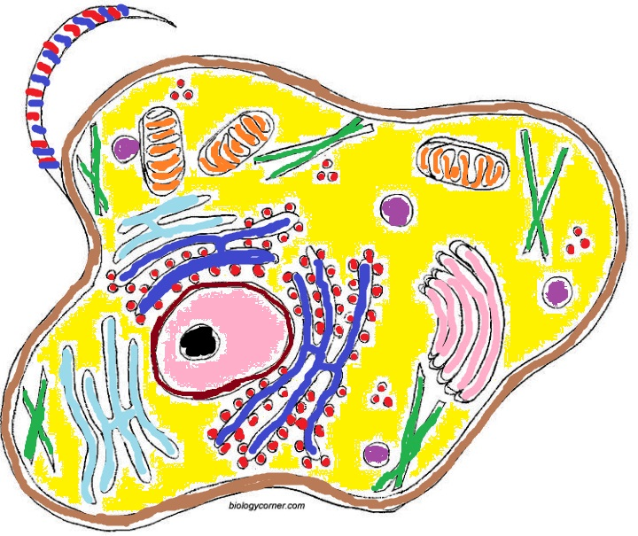
II. Briefly describe the function of the cell parts.
1. Cell membrane _____barrier between cell and outside_____________
2. Endoplasmic Reticulum ____cell transport_____________________________
3. Ribosome _________makes proteins________________________________
4. Golgi Apparatus ___packaging, processing, secreting vesicles____________________
5. Lysosome _____breaks down substances________________________
6. Microtubule _____cytoskeleton, cell support___________________________
7. Mitochondria _____produces energy for cell; cell respiration______________________________
8. Nucleus _____control center, contains DNA _______________________________

